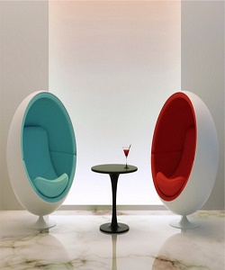

Edra chair

$77.79

Availability: In stock

Description

Modern ball chairs, the perfect mixture of fun design with surprising comfort and staying power. Easy does it. Solid rubber and classic are well matched in this white finish chair. Edra bringing the best of products of chair at the best prices!